A Case Study of Ambient Air Quality Monitoring and preparation of wind-rose diagram for Mandoli Redevelopment Area Delhi, India using Rammet view
Shyam Sunder¹, Mohammed Sharif², Nandita Moitra³, Pintu Kumar⁴
¹PhD. Student ²Professor and guide Dept. of Civil Engineering, Jamia Milia Islamia University,
³Sr. Scientist, Delhi Pollution Control Committee ⁴Free Lance Scientist
---------------------------------------------------------------------***---------------------------------------------------------------------

Abstract -Delhi is considered as one of the highly air polluted cities in the world, to improve the air quality of Delhi, way back in 1987 by a central law, Delhi has been declared as an air polluting zone. The main reason of air pollution in Delhi is its unplanned and haphazard growth which leads to the establishment of air polluting industrial units in planed and un-planed manner, releasing different pollutants in the atmosphere. The area for air modelling is chosen because, it is considered to be one of a major air polluting zone in Delhi. The objective of the modelling to determine and predict the concentration of particulate matter in terms of PM₁₀ and PM_{2.5} released from different point and elevated emission sources during winter and summer season. This study focuses on how to apply a dispersion model in these types of urban area, where model input data and data from air quality monitoring stations are limited etc. 8hourly extensive and passive ambient air monitoring at three established stations for 72 hours in winter as well as in summer season in year 2019 were conducted accordingly using Fine Particulate Sampler and Respirable Dust Sampler. The meteorological data was proved by Central Pollution Control Board. The results from ambient air monitoring show that the distributions of PM₁₀ & PM_{2.5} are quite high as compared to the prescribed standard limits. Although the prediction was made based on the basis of 8 hourly monitoring, however, it would be necessary to use a Short/Long-term model to determine the pollution potential and dispersion of particulate using air quality dispersion models.
Key Words: Air Polluting Zone, Fine and Suspended Particulate Matter, Air Quality Monitoring.

1. INTRODUCTION
Air pollution has emerged as a major challenge, particularly in urban areas. The problem becomes more complex due to multiplicity and complexity of air polluting source mix (e.g., industries, automobiles, generator sets, domestic fuel burning, road side dusts, construction activities, etc.). Being a major center of commerce, industry and education, Delhi has experienced a phenomenal growth in recent years. Like many other large cities, the City of Delhi is adversely affected by problems of urbanization. The burgeoning population coupled with rapid growth in terms of vehicles, construction, and energy consumption has resulted in serious environmental concerns in Delhi. However, with urbanization, industrial and economic growth the price of rapid development had been paid through introduction of pollutants in the atmosphere having complex and long residence time resulting in degraded state of air quality (Seinfeld and Pandis, 2006; Stott and Tett et.al., 2000; Ramanathan and Crutzen et.al., 2001). In recent years, understanding the physical, chemical and biological properties of aerosols and other air pollutants a special emphasis has been given to study the deleterious impact on ecology and human health. The various studies had shown critical relation for air-pollutants becoming a main cause for respiratory diseases and reducing human longevity (Johnson, 2004; Pope, 2000; Pope and Dockery et.al. 2006). The sustained exposure of increased particle concentration may lead to chronic respiratory diseases, frequent hospital admissions, premature child births and lower life expectancy (Greenstone and Nilekani et.al. 2015; Mathew and Goyal et.al. 2013). The earlier work had shown that the aerosol particles play a significant part role in climate change and cloud condensation nuclei process through their light absorbing properties (Poschl, 2005; Bond and Bergstrom, 2006; Krishna, 2012) which may alter the reflectivity from earth surface. The Particulate matter (PM) or aerosol is a suspension of liquid or solid particles in atmosphere. They are studied through the standard point space they occupy in size range spectrum under different categories. From the human health perspective, it has been divided into coarse, fine and ultrafine particles. The particles with aerodynamic diameter less than or equal to 10 micrometers are called PM₁₀ which on inhalation through respiration can reach the upper part of nasal cavity and airways in humans. The particles with diameter of 2.5 micrometers or lesser are called PM_{2.5} that can pass further into lungs reaching till thoracic region. The particles with diameter lesser than 1.0 micrometer are referred as PM_{1.0} which represent the danger of reaching deep into alveoli sac region where they can get mixed with the blood and harms the vital organs of the body (Pope, 2000; Briggs, 2003 and Johnson, 2004). The ambient air of an area would be affected by the kind of various activities prevalent in that region. The removal process of aerosol particles from air depends on the size of particles. The particles with fine aerodynamic diameter settles within few hours while coarser particles get settled in few days through various dry and wet deposition processes (Pope and Dockery et.al., 2006; Raes and Van et.al., 2000). The developing countries in particular are at higher risk of pollution exposure since the techniques measures to check and reduce the pollution levels are not well-equipped.
Aerosol’s have a lifetime of about few days to a week comes predominantly from numerous anthropogenic combustion sources such as vehicles, power plants, industries and residential cooking / heating activities, solid waste incineration and agricultural residue burning after harvest. These particles majorly contain carbonaceous compounds (elemental and organic), water-soluble ions and trace elements. Once emitted, the particles go through complex chemical reactions and rapid transformation in the atmosphere, leading to modification in the size and composition of aerosol. Though aerosols are locally emitted from sources, they can be transported to thousands of Kilometers by wind resulting in extended climatic impacts and changes.
In recent time’s unexpected increase in aerosol particles concentration in air have felt the need for firm monitoring of pollutants in different activity based regions. Different studies have indicated that assessment needs to account for various land use based emission activities such as for residential, industrial, and institutional etc. (Guttikunda, 2012; Yadav and Sahu et.al., 2014). The personal exposure to people while commuting also accounts for vehicular emission which affects health and has become a menace in Delhi (Kumar et.al. 2014; Kumar and Gupta, 2013; Guttikunda and Goel et al., 2014). Being a metropolitan city, Delhi serves as national commercial hub for several domestic, national and international activities. The city presents a good network of pollution monitoring station deployed by various agencies keeping a check on level of air pollutant in different areas.
Respirable Dust Sampler tilt back the inlet. Loosen the faceplate wing nuts and remove the faceplate. Remove the filter from its jacket and center it on the support screen with the rough side of the filter facing upwards. Replace the faceplate and tighten the wing nuts to secure the rubber gasket against the filter edge. Gently lower the inlet. For automatically flow controlled units, record the designated flow rate on the data sheet. Record the reading of the elapsed time meter. The specified length of sampling is commonly 8 hours or 24 hours. During this period, several reading (hourly) of flow rate should be taken.
After the required time of sampling, record the flow meter reading, take out the filter media from the sampler, and put in a container or envelop.
Micro-meteorology data was collected from nearest DPCC online weather station i.e Vivek Vihar (28.672342E, 77.315260N) needed for wind-rose diagram preparation including hourly wind speed, direction, ambient temperature, ambient pressure etc. Mixing height was extracted from the Atlas of Hourly Mixing Height and Assimilative Capacity of Atmosphere in India published by India Meteorological Dept. for Winter and Summer season around India.
2. MATERIALS AND METHOD
PM₁₀ Determination in Ambient air
Air is drawn through Respirable Dust Sampler (RDS) a size-selective inlet and through a 20.3 X 25.4 cm (8 X 10 in) filter at a flow rate, which is typically 1.1 to 1.2 m³/min. Particles with aerodynamic diameter less than the cut-point of the inlet are collected, by the filter. The mass of these particles is determined by the difference in filter weights prior to and after sampling. The concentration of PM in the designated size range is calculated by dividing the weight 10 gain of the filter by the volume of air sampled.
Instrument/Equipment
The following items are necessary to perform the monitoring and analysis of Particulate Matter PM₁₀ in ambient air:
- Analytical balance:
- Sampler : Respirable Dust Sampler (RDS) with size selective inlet for PM10 and automatic volumetric flow control
- Calibrated flow-measuring device to control the airflow at 1.1-1.2 m³/min.
- Top loading orifice kit.
- Filter Media : A Glass fibre filter of 20.3 X 25.4 cm (8 X 10 in) size
Sampling :
Tilt back the inlet and following the SOP of manufacturer's instructions. Loosen the faceplate wing nuts and remove the faceplate. Remove the filter from its jacket and centre it on the support screen with the rough side of the filter facing upwards. Replace the faceplate and tighten the wing nuts to secure the rubber gasket against the filter edge. Place the filter media between filter edge, insure that filter media number is always downward so that numbering on filter media is not disappear due to particulate matter deposition on Filter media. Gently lower the inlet. For automatically flow controlled units, record the designated flow rate on the data sheet. Record the reading of the elapsed time meter. The specified length of sampling is commonly 8 hours or 24 hours. During this period, several reading (hourly) of flow rate should be taken. After the required time of sampling, record the flow meter reading, take out the filter media from the sampler, and put in a container or envelope.
Analysis:
Inspect the filter for pin holes using a light table. Loose particles should be removed with a soft brush. Note down the filter number. Condition the filter in conditioning room maintained within 20-30°C and 40-50% relative humidity or in an airtight desiccator for 24 hours. Taken initial weight of the filter paper (Wi) before sampling. Condition the filter after sampling in conditioning room maintained within 20-30°C and 40-50% relative humidity or in an airtight desiccator for 24 hours. Take final weight of the filter paper (Wf).
Calculation of PM10:
CPM₁₀ µg/m = (Wf - Wi) x 10⁶ / V
Where,
CPM = Concentration of PM₁₀, µg/m3
Wf = Final weight of filter in g
Wi = Initial weight of filter in g
10⁶ = Conversion of g to µg
V = Volume of air sampled, m³
PM_{2.5} Determination in Ambient air:
PM refers to fine particles that are 2.5 micrometers (µm) or smaller in diameter. 2.5 Ambient air is defined as any unconfined part of the Earth's atmosphere, that the surrounding outdoor air in which humans and other organisms live and breathe.
An electrically powered air sampler draws ambient air at a constant volumetric flow rate (16.7 lpm) maintained by a mass flow / volumetric flow controller coupled to a microprocessor into specially designed inertial particle-size separator (i.e. cyclones or impactors) where the suspended particulate matter in the PM size ranges is separated 2.5 for collection on a 47 mm polytetrafluoroethylene (PTFE) filter over a specified sampling period. Each filter is weighed before and after sample collection to determine the net gain due to the particulate matter. The mass concentration in the ambient air is computed as the total mass of collected particles in the PM size ranges divided by the 2.5 actual volume of air sampled, and is expressed in µg/m . The microprocessor reads averages and stores five-minute averages of ambient temperature, ambient pressure, filter temperature and volumetric flow rate. In addition, the microprocessor calculates
the average temperatures and pressure, total volumetric flow for the entire sample run time and the coefficient of variation of the flow rate.
Sampling Requirement:
Samplers should be sited to meet the goals of the specific monitoring project. For routine sampling to determine compliance with the National Ambient Air Quality Standards (NAAQS), sampler sitting is described in CPCB guidelines shall apply The monitoring should be done at outside the zone of influence of sources located within the designated zone of representation for the monitoring site.
Height of the inlet must be 3 - 10 m above the ground level. And at a suitable distance from any direct pollution source including traffic. Large nearby buildings and trees extending above the height of the monitor may present barriers or deposition surfaces for PM. Distance of the sampler to any air flow obstacle i.e. buildings, must be more than two times the height of the obstacle above the sampler.
There should be unrestricted airflow in three of four quadrants. Certain trees may also be sources of PM in the form of detritus, pollen, or insect parts. These can be avoided by locating samplers by placing them > 20 m from nearby trees. If collocated sampling has to be performed the minimum distance between two Samplers should be 2 m.
Sampling Apparatus and Material:
Sampling equipment designated as FRM (Federal Reference Method) or FEM (Federal Equivalent Method)
— Certified Flow Transfer Standard for Flow Calibration.
Following established EPA methods and procedures, all calibration transfer standards (i.e. temperature, pressure and flow) must be certified against traceable standards at least once per year. Calibration of these transfer standards will be conducted by the transfer standard manufacturer.
— Certified Standards for Pressure and Temperature (Optional)
— Electronic microbalance with a minimum resolution of 0.001 mg and a precision of ± 0.001 mg, supplied with a balance pan. The microbalance must be positioned on a vibration-damping balance support table.
— Calibration weights, utilized as Mass Reference Standards, should be noncorroding, range in weight from 100 mg to 200 mg, and be certified as traceable to NIST mass standards. The weights should be ASTM Class 1 category with a tolerance of 0.025 mg.
— Non-serrated forceps for handling filters.
— Non-metallic, non-serrated forceps for handling weights.
— Digital timer/stopwatch.
47 mm Filter: Teflon membrane, 46.2 mm effective diameter with a polypropylene support ring or filters as recommended by FRM / FEM sampler manufacturer.
— Filter support cassettes and covers.
— Filter equilibration racks.
— Relative Humidity / Temperature recorder.
— NIST-certified or ISO traceable Hygrometer for calibration of relative humidity readings.
— NIST-certified ISO traceable Thermometer for calibration of temperature readings.
— Light box.
— Radioactive (alpha particle) Polonium-210 ("Static Master") antistatic strips for static charge neutralization however static charge gives low-moderate interference in stability of reading of balance.
— Antistatic, nitrate-free, phosphate-free, sulphate-free, and powder free vinyl gloves.
— Plastic petri-slide filters containers (Filter Cassette).
— Zip-lock plastic bags, 6" 9".
— Disposable laboratory wipes.
— Filter equilibration cabinets.
— Impactor oil/grease
The higher pollutant concentration of PM₁₀ and PM_{2.5} in the area is due un-controlled fugitive emission dispersion by the industries burning adulterated fuel oil in the melting, heating and casting furnaces in which ferrous and non-ferrous metal scrap melted to obtained/recover metal for reuse, pulverizing process in which metal is recovered by grinding of furnace residues i.e. slag, dross and Kreet etc. Although industrial units having air pollution control devices but the results shows that either the installed devices are not adequate to control the released pollutants or the industrial units not operating the installed emission control devices and let bypassing the entire flue gases, fugitive emissions in to the atmosphere resulting excessive results of PM₁₀ and PM_{2.5}. Most of the units might not have adequate hoods and suction results in to escape flue gases, fugitive emissions to the surroundings. The type of fuel being used by the industries in the melting, casting and heating furnaces also contributed the higher value of PM₁₀ and PM_{2.5}. To gain more profit and stay in the competition, the industrial units using substandard in quality fuel may also leads in higher concentration of PM₁₀ and PM_{2.5}. The fuel like Carbon Black Feed Stock (CBFS), have carbon content more than 80% v/v and furnace oil, which is almost last fragment in distillation of an oil refinery and highly viscous and also the adulterated impure form of Rubber Processed Oil and Tyre Oil obtained during condensation of an abstract procured during the pyrolysis process of waste/discarded rubber tyre might also leads to contribute in the higher value of PM₁₀ and PM_{2.5}. The impact due to domestic and vehicular has been not considered, as it has been very less for PM₁₀ and PM_{2.5}.
Hence, it can be say that the ferrous and non-ferrous metal scrap melting and casting industries and industries engaged in the work of pulverization are responsible for higher contribution of PM₁₀ and PM_{2.5}.
The wind rose for winter season data collected from the Vivek Vihar continuous Ambient Air quality monitoring station as shown in Chart-1 indicates that the predominant direction for the wind is West, North-East. It has been observed that during winter season, the wind speed is low, with 80% of time wind speed being calm and less than 2.10m/s. Under low wind speed conditions, the particulate matters do not disperse. They accumulate at the place of emission i.e. there is no actual movement of pollutants from one place to another under low wind speed. The same can be seen in Chart-1, that the higher concentrations of PM₁₀ & PM_{2.5} are obtained near the different emission sources. When higher winds are flowing, the pollutants which are accumulated at the time of low winds are transported in the North east direction, since the wind is, most of the time, predominating from West, North-East. It has been observed that the concentrations at the receptor, away from the sources have been less compared to receptors nearest sources.
3. RESULTS AND DISCUSSION
It is to say that the concentration of pollutants is decreasing as the downwind distance between the receptor and point sources is increasing which approves the working of Earldom 8.9 model’s in principle. An analysis of meteorological data shows that, during winter season in the month of January most of the time the atmospheric condition in the region has been stable. In winter months, due to occurrence of low wind speeds and stable atmosphere conditions, the concentration of PM10 and PM2.5 has been found very high.
The Annual wind rose diagram of 2019 as shown in Chart 1 indicates that prevailing predominant direction for the wind is West-North-East with an average occurrence has been found to be more than 60%. It has been observed that during summer season, the wind speed is higher as compared to winter season. The occurrences of the stable conditions have also been much lower than winter season. Due to stronger convective conditions in summer, the average mixing height found high. All these factors are favourable for the dispersion of pollutants resulting low concentration of pollutants as compared to winter season.
Considering the post Covid 19 pandemic scenario, the commercial activities are already started supporting the increment in the level of ambient air pollutant.
The frequency count and frequency distribution of windrose diagram are presented in Table1&2.
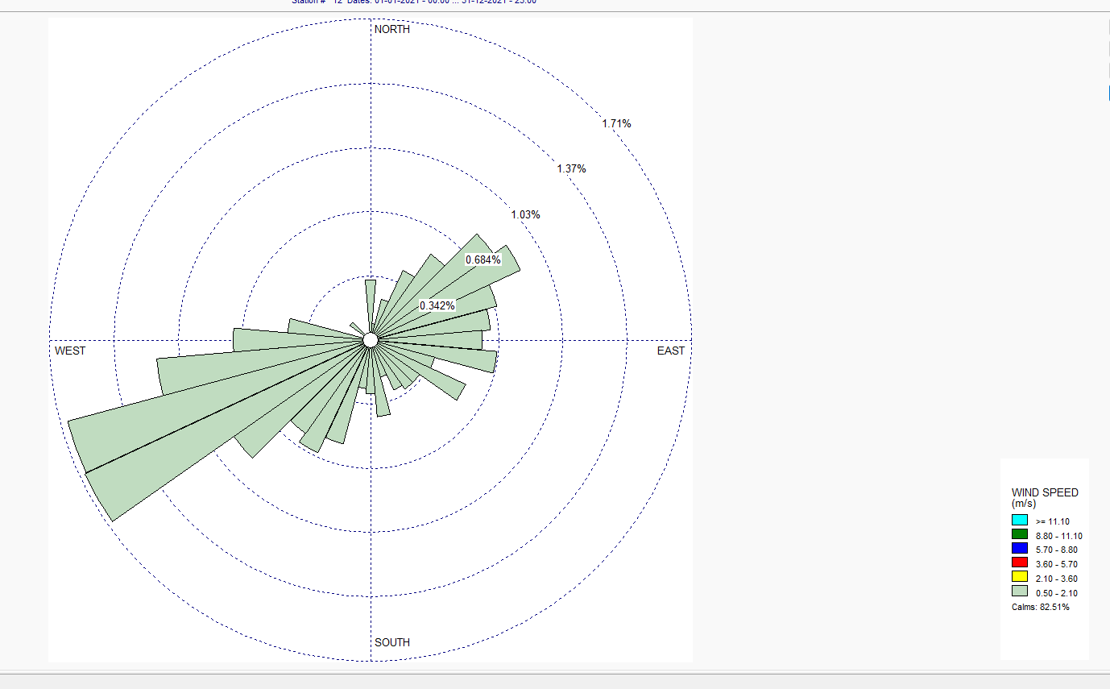
Chart- 1: Windrose Diagram of Vivek Vihar near Mandoli area

S.No. | Directions /  Wind Classes (m/s) | 0.50 –  2.10 | 2.10 –  3.60 | 3.60 –  5.70 | 5.70 –  8.80 | 8.80 –  11.10 | >= 11.10 | Total
1 | 355 - 5 | 28 | 0 | 0 | 0 | 0 | 0 | 28
2 | 5-15 | 8 | 0 | 0 | 0 | 0 | 0 | 8
3 | 15 - 25 | 20 | 0 | 0 | 0 | 0 | 0 | 20
4 | 25 - 35 | 36 | 0 | 0 | 0 | 0 | 0 | 36
5 | 35 - 45 | 49 | 0 | 0 | 0 | 0 | 0 | 49
6 | 45 - 55 | 70 | 0 | 0 | 0 | 0 | 0 | 70
7 | 55 - 65 | 77 | 0 | 0 | 0 | 0 | 0 | 77
8 | 65 - 75 | 61 | 0 | 0 | 0 | 0 | 0 | 61
9 | 75 - 85 | 56 | 0 | 0 | 0 | 0 | 0 | 56
10 | 85 - 95 | 52 | 0 | 0 | 0 | 0 | 0 | 52
11 | 95 - 105 | 59 | 0 | 0 | 0 | 0 | 0 | 59
12 | 105 - 115 | 31 | 0 | 0 | 0 | 0 | 0 | 31
13 | 115 - 125 | 49 | 0 | 0 | 0 | 0 | 0 | 49
14 | 125 - 135 | 28 | 0 | 0 | 0 | 0 | 0 | 28
15 | 135 - 145 | 28 | 0 | 0 | 0 | 0 | 0 | 28
16 | 145 - 155 | 26 | 0 | 0 | 0 | 0 | 0 | 26
17 | 155 - 165 | 18 | 0 | 0 | 0 | 0 | 0 | 18
18 | 165 - 175 | 36 | 0 | 0 | 0 | 0 | 0 | 36
19 | 175 - 185 | 25 | 0 | 0 | 0 | 0 | 0 | 25
20 | 185 - 195 | 23 | 0 | 0 | 0 | 0 | 0 | 23
21 | 195 - 205 | 50 | 0 | 0 | 0 | 0 | 0 | 50
22 | 205 - 215 | 58 | 0 | 0 | 0 | 0 | 0 | 58
23 | 215 - 225 | 53 | 0 | 0 | 0 | 0 | 0 | 53
24 | 225 - 235 | 78 | 0 | 0 | 0 | 0 | 0 | 78
25 | 235 - 245 | 147 | 0 | 0 | 0 | 0 | 0 | 147
26 | 245 - 255 | 146 | 0 | 0 | 0 | 0 | 0 | 146
27 | 255 - 265 | 100 | 0 | 0 | 0 | 0 | 0 | 100
28 | 265 - 275 | 64 | 0 | 0 | 0 | 0 | 0 | 64
29 | 275 - 285 | 39 | 0 | 0 | 0 | 0 | 0 | 39
30 | 285 - 295 | 3 | 0 | 0 | 0 | 0 | 0 | 3
31 | 295 - 305 | 2 | 0 | 0 | 0 | 0 | 0 | 2
32 | 305 - 315 | 12 | 0 | 0 | 0 | 0 | 0 | 12
33 | 315 - 325 | 0 | 0 | 0 | 0 | 0 | 0 | 0
34 | 325 - 335 | 0 | 0 | 0 | 0 | 0 | 0 | 0
35 | 335 - 345 | 0 | 0 | 0 | 0 | 0 | 0 | 0
36 | 345 - 355 | 0 | 0 | 0 | 0 | 0 | 0 | 0
 | Sub-Total | 1532 | 0 | 0 | 0 | 0 | 0 | 1532
 | Calms |  |  |  |  |  |  | 7228
 | Total |  |  |  |  |  |  | 8760

Table - 1: Frequency count of the wind rose
S. No. | Directions /  Wind Classes (m/s) | 0.50 –  2.10 | 2.10 –  3.60 | 3.60 –  5.70 | 5.70 –  8.80 | 8.80 –  11.10 | >= 11.10 | Total
1 | 355 - 5 | 0.003 | 0.000 | 0.000 | 0.000 | 0.000 | 0.000 | 0.003
2 | 5-15 | 0.001 | 0.000 | 0.000 | 0.000 | 0.000 | 0.000 | 0.001
3 | 15 - 25 | 0.002 | 0.000 | 0.000 | 0.000 | 0.000 | 0.000 | 0.002
4 | 25 - 35 | 0.004 | 0.000 | 0.000 | 0.000 | 0.000 | 0.000 | 0.004
5 | 35 - 45 | 0.006 | 0.000 | 0.000 | 0.000 | 0.000 | 0.000 | 0.006
6 | 45 - 55 | 0.008 | 0.000 | 0.000 | 0.000 | 0.000 | 0.000 | 0.008
7 | 55 - 65 | 0.009 | 0.000 | 0.000 | 0.000 | 0.000 | 0.000 | 0.009
8 | 65 - 75 | 0.007 | 0.000 | 0.000 | 0.000 | 0.000 | 0.000 | 0.007
9 | 75 - 85 | 0.006 | 0.000 | 0.000 | 0.000 | 0.000 | 0.000 | 0.006
10 | 85 - 95 | 0.006 | 0.000 | 0.000 | 0.000 | 0.000 | 0.000 | 0.006
11 | 95 - 105 | 0.007 | 0.000 | 0.000 | 0.000 | 0.000 | 0.000 | 0.007
12 | 105 - 115 | 0.004 | 0.000 | 0.000 | 0.000 | 0.000 | 0.000 | 0.004
13 | 115 - 125 | 0.006 | 0.000 | 0.000 | 0.000 | 0.000 | 0.000 | 0.006
14 | 125 - 135 | 0.003 | 0.000 | 0.000 | 0.000 | 0.000 | 0.000 | 0.003
15 | 135 - 145 | 0.003 | 0.000 | 0.000 | 0.000 | 0.000 | 0.000 | 0.003
16 | 145 - 155 | 0.003 | 0.000 | 0.000 | 0.000 | 0.000 | 0.000 | 0.003
17 | 155 - 165 | 0.002 | 0.000 | 0.000 | 0.000 | 0.000 | 0.000 | 0.002
18 | 165 - 175 | 0.004 | 0.000 | 0.000 | 0.000 | 0.000 | 0.000 | 0.004
19 | 175 - 185 | 0.003 | 0.000 | 0.000 | 0.000 | 0.000 | 0.000 | 0.003
20 | 185 - 195 | 0.003 | 0.000 | 0.000 | 0.000 | 0.000 | 0.000 | 0.003
21 | 195 - 205 | 0.006 | 0.000 | 0.000 | 0.000 | 0.000 | 0.000 | 0.006
22 | 205 - 215 | 0.007 | 0.000 | 0.000 | 0.000 | 0.000 | 0.000 | 0.007
23 | 215 - 225 | 0.006 | 0.000 | 0.000 | 0.000 | 0.000 | 0.000 | 0.006
24 | 225 - 235 | 0.009 | 0.000 | 0.000 | 0.000 | 0.000 | 0.000 | 0.009
25 | 235 - 245 | 0.017 | 0.000 | 0.000 | 0.000 | 0.000 | 0.000 | 0.017
26 | 245 - 255 | 0.017 | 0.000 | 0.000 | 0.000 | 0.000 | 0.000 | 0.017
27 | 255 - 265 | 0.011 | 0.000 | 0.000 | 0.000 | 0.000 | 0.000 | 0.011
28 | 265 - 275 | 0.007 | 0.000 | 0.000 | 0.000 | 0.000 | 0.000 | 0.007
29 | 275 - 285 | 0.004 | 0.000 | 0.000 | 0.000 | 0.000 | 0.000 | 0.004
30 | 285 - 295 | 0.000 | 0.000 | 0.000 | 0.000 | 0.000 | 0.000 | 0.000
31 | 295 - 305 | 0.000 | 0.000 | 0.000 | 0.000 | 0.000 | 0.000 | 0.000
32 | 305 - 315 | 0.001 | 0.000 | 0.000 | 0.000 | 0.000 | 0.000 | 0.001
33 | 315 - 325 | 0.000 | 0.000 | 0.000 | 0.000 | 0.000 | 0.000 | 0.000
34 | 325 - 335 | 0.000 | 0.000 | 0.000 | 0.000 | 0.000 | 0.000 | 0.000
35 | 335 - 345 | 0.000 | 0.000 | 0.000 | 0.000 | 0.000 | 0.000 | 0.000
36 | 345 - 355 | 0.000 | 0.000 | 0.000 | 0.000 | 0.000 | 0.000 | 0.000
 | Sub-Total | 0.175 | 0.000 | 0.000 | 0.000 | 0.000 | 0.000 | 0.175
 | Calms |  |  |  |  |  |  | 0.825
 | Total |  |  |  |  |  |  | 1

Table- 2: Frequency Distribution of Windrose diagram

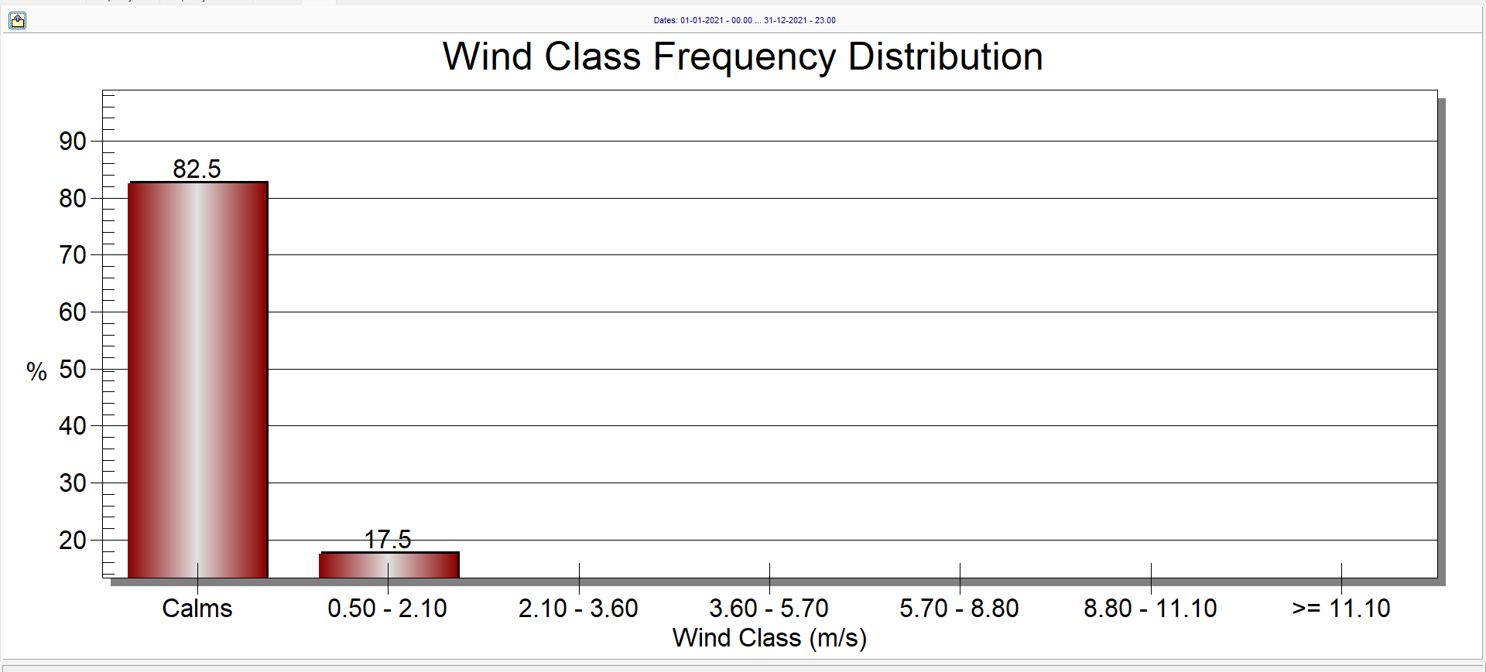
Chart - 2: Wind rose diagram graph

All the particulate matter i.e PM10 and PM2.5 during Summer and Winter season is found high with compare to National Ambient air quality Standard.
The model was run considering the Multi run / Worst case approach. In this approach model itself estimate the wind direction for worst case scenario pollution load assessment. This approach negates the variation of prediction due to wind angle.

4. CONCLUSIONS

The study of air pollution and air quality monitoring and preparation of wind rose diagram prediction is done through Aermod 11.2.0 is model based upon.
The ambient air monitoring has been conducting by obtaining Baseline data of Ambient Air Quality was generated at three locations in New Mandoli Industrial area. Station No. 1(S-1) was set at Co-ordinate 28º 42’ 46’’N, 77 º 19’ 01’’E. Station no. 2 (S-2) was set at Co-ordinate 28 º 42’ 22’’N, 77 º 18’ 53’’E and Station no. 3 (S-3) was set at 28 º 42’ 37.25’’ 77 ºN, 18’ 27.91’’E. Maximum concentration of PM₁₀ during January is 582µg/m³ at S-1 and during April is 861µg/m³ at S-2. Maximum concentration of PM_{2.5} during January is 505µg/m³ at S-2 and during April is 320 µg/m³ at S-2.
Finally, it can be concluded that the situation can be controlled by improving every source individually as well as by improving all the parameters of the model as per Indian conditions. Futher study of air quality dispersion modeling and comparision of automatic weather station and monitoring ambient air quality monitoring is required.

REFERENCES

- Pintu Kumar, Syed Khursheed Ahmad, Saurabh Kumar Garg, Shivani (2020), Air Quality Prediction Modeling for Badarpur to NHPC Chowk Faridabad, Delhi-NCR, India using Caline 4.
- Saurabh Kumar Garg, Syed Khursheed Ahmad, Pintu Kumar, Shivani(2020), Air Quality Prediction Modeling for Dwarka Sector 13-14 Circle, New Delhi, India using Caline 4.
- Humaib Nasir, Kirti Goyal and Dolonchapa Prabhakar (2016), ‘Review of Air Quality Monitoring: Case Study of India’.
- C. P. Kaushik, Ravindra Khaiwal, Krishan Yadav, Surender Mehta and A. K. Haritash (2006), ‘Assessment of Ambient Air Quality in Urban Centres of Haryana (India) in Relation to Different Anthropogenic Activities and Health Risks’.
- Lakshmi Rajagopalan and Sarah Lamothe (2015), ‘Urban Air Pollution Data in India: Gaps Between Regulations and Reality’
- Pallavi Pant & Raj M. Lal & Sarath K. Guttikunda & Armistead G. Russe & Ajay S. Nagpure & Anu Ramaswami & Richard E. Peltier (2018), ‘Monitoring particulate matter in India: recent trends and future outlook’
- Umesh Chandra and Kamal Jain (2013), ‘Web Based Ambient Air Quality Monitoring System for Delhi’.
- Laura E. Venegas and Nicolás A. Mazzeo (2013), ‘A Method for Selection of Background Air Quality Monitoring Sites in an Urban Area’
- R. Angle Consulting (2014), ‘Ambient Air Quality Objectives’
- Xingzhe Xie, Ivana Semanjski, Sidharta Gautama, Evaggelia Tsiligianni, Nikos Deligiannis, Raj Thilak Rajan, Frank Pasveer and Wilfried Philips (2017), ‘A Review of Urban Air Pollution Monitoring and Exposure Assessment Methods’
- Sharma and Dikshit et.al (2016) Identify and inventories emission sources (industry, traffic, power plants, local power generation, small scale industries etc.) in Delhi.
- Baijayanta Kumar Majumdar, Amit Dutta, Shibnath Chakraborty and Subhabrata Ray (2009), ‘Assessment of vehicular pollution in Kolkata, India, using CALINE 4 model’
- Bhattacharya et.al (2015) “Particulate matter load at different aerodynamic diameter for two seasons of an urban industrial site in Delhi using portable aerosol spectrometer”.
- Rout Chadetrik, Gulia Sunil and Saini Mukesh (2015), ‘Air Quality Prediction along a Highway Corridor under Mixed Traffic Condition’
- Raman et.al (2016) Fine aerosol fraction (particulate matter with aero- dynamic diameter <= 1.0 μm (PM_{1.0}) over the Indian Institute of Technology Delhi campus Validation of air pollution dispersion modeling for the road transport sector under Irish conditions (2000-LS-6.3-M1)
- Performance evaluation of air quality dispersion models at urban intersection of an Indian city: A case study of Delhi city
- Mayer, H., Air pollution in cities. Atmospheric Environment (1999), pp. 4029- 4037
- Sharma, N., Chaudhry, K.K. and Rao, C.V.C., Vehicular pollution modeling in India. Journal of the Institution of Engineers (India), (2005), pp. 46-63
- Badami, M. G., Urban transport policy as if people and the environment mattered: Pedestrian accessibility the first step. Economic & Political Weekly, EPW Vol. XLIV (33), 2009
- CPCB, Status of vehicular pollution control program in India, Program Objective Series/PROBES/136/2010
- CPCB, Guidelines for the Measurement of Ambient Air Pollutants (Vol-1)

BIOGRAPHIES (Optional not mandatory)

 | Shyam Sunder has 35+ years of progressive experience in the field of designing and construction of low-cost sanitation plants, implementation of Environmental Laws, designing and execution of Air Pollution Control Devices, Environmental Auditing of Sewage Treatment Pants, CETP and Thermal Power Plants and EIA assessments.

